**Configuration – Samitee & Member (Samitee)**  
Bug Report

Cycle 1

Afrida Rahman

Last Executed: 23/05/2024

**Samitee:**

* Registration
* New Samitee Authorization
* Information Change

**Samitee module**

1. System should suggest district and upazila under selected Division in Samitee module. Though it is head office id “PSBSYSTEM”, it should not suggest other districts and upazila.

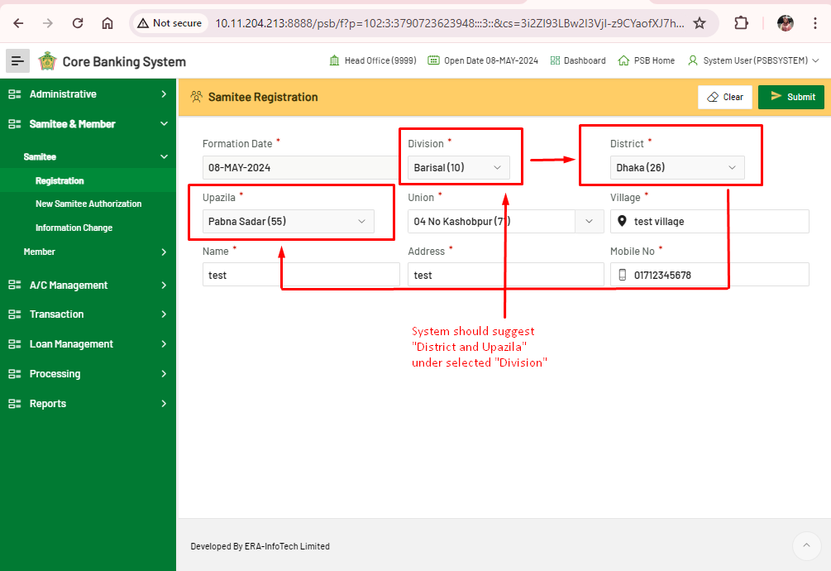

1. From ”PSBSYSTEM” cannot view samitee registration request from PSBUSER06 in Samitee module.

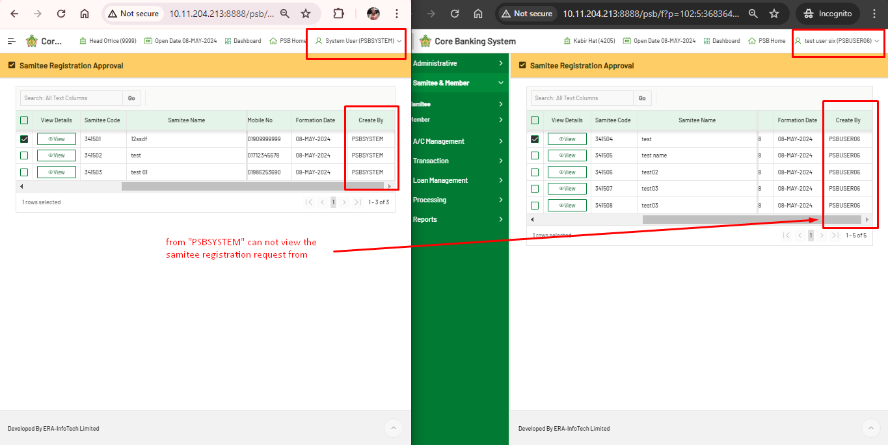

1. Error in edit Information Change in Samitee module. Even information change request authorization is not in “PSBSYSTEM” account.

